2021 Unit 3_4 Chemistry trial exam

Name: ____________________

Section A: Multiple Choice section

Use the following information to answer Questions 1 and 2.
A snippet from a student’s notes is shown below.
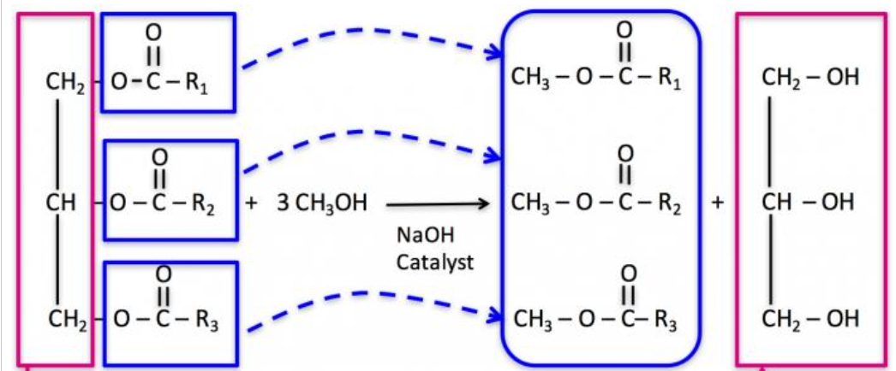

Question 1
The equation the diagram represents is
A. fatty acid + alcohol 3biodiesel + glycerol
B. fatty acid + 3alcohol 3biodiesel + glycerol
C. triglyceride + 3alcohol 3fatty acid + glycerol
D. triglyceride + 3alcohol 3biodiesel + glycerol

Question 2
The fuel formed
A. is non-renewable as the raw material is a component of crude oil.
B. has the highest energy density of any of the common fuels.
C. is considered renewable as crops required can be grown each year.
D. is good for the environment as it does not lead to the production of any CO₂ emissions.

Question 3
The volume of oxygen required at SLC to react completely with 2 mol of ethane will be, in litres,
A. 49.6
B. 74.4
C. 99.2
D. 174

Question 4
Which one of the following statements about viscosity is correct?
A. The viscosity of biodiesel from stearic acid is higher than that of biodiesel from lauric acid.
B. The viscosity of biodiesel from linolenic acid is higher than that of biodiesel from stearic acid.
C. The viscosity of bioethanol is higher than that of biodiesel.
D. The viscosity of petrodiesel is usually higher than that of biodiesel.

Question 5
An energy profile diagram is shown below.
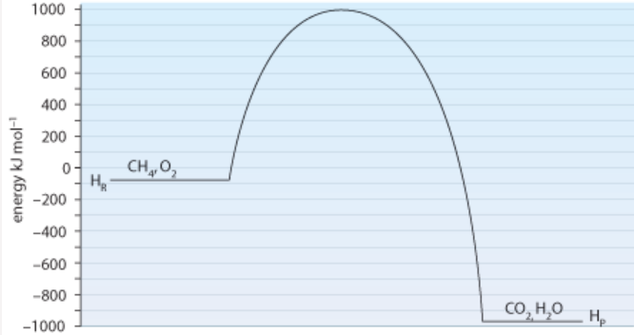

Which alternative correctly shows the activation energy and enthalpy change of the reverse reaction?
A. +1990 kJ mol⁻¹ and -900 kJ mol⁻¹
B. +1990 kJ mol⁻¹ and +900 kJ mol⁻¹
C. +1090 kJ mol⁻¹ and -900 kJ mol⁻¹
D. +1090 kJ mol⁻¹ and +900 kJ mol⁻¹

Question 6
The reaction between hydrogen and iodine gases is

H₂(g) + I₂(g) ⇄ 2HI(g)

A catalyst is added to an equilibrium mixture of the above gases. The catalyst
A. will not impact the rate as the system is at equilibrium.
B. will increase the rate of the forward reaction.
C. will lead to an increase in the value of K_{c}.
D. will increase the rate of the forward reaction but not the back reaction.

Use the following information to answer Questions 7 and 8
The equation for the decomposition of ammonia is:

2NH₃(g) ⇄ N₂(g) + 3H₂(g) K_{c} = 3.4 x 10⁶ at 700 ⁰C ∆H = + 93 kJ mol⁻¹

Question 7
A sample of ammonia is added to an empty reactor at 700 ⁰C. When equilibrium is reached
A. [N₂] = ½ [NH₃]
B. [N₂] = 3[H₂]
C. [N₂] > [NH₃]
D. [NH₃] > [N₂]

Question 8
A change is made to a 1.0 L equilibrium mixture of the above gases. After equilibrium is re-established the amounts have changed by:

NH₃ increased by 0.2 mol N₂ increased by 0.02 mol H₂ decreased by 0.3 mol

The change could have been
A. a decrease in temperature.
B. a decrease in volume.
C. an increase in volume.
D. an increase in the amount of nitrogen gas.

Question 9
The units for the equilibrium constant for a reversible reaction is M². The equation could be
A. 2SO₂(g) + O₂(g) ⇄ 2SO₃(g)
B. N₂(g) + 3H₂(g) ⇄ 2NH₃(g)
C. H₂(g) + I₂(g) ⇄ 2HI(g)
D. CH₄(g) + H₂O(g) ⇄ CO(g) + 3H₂(g)

Use the following information to answer questions 10 and 11
The diagram shows a cross section of a zinc, manganese dioxide cell that operates in alkaline conditions.
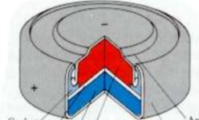
The MnO₂ half equation occurring is
2MnO₂(s) + H₂O(l) + 2e⁻ Mn₂O₃(s) + 2OH⁻(aq)

Question 10
In this cell, the MnO₂
A. is being reduced at the cathode.
B. is reducing zinc ions to zinc atoms.
C. is a catalyst for the reduction of hydrogen atoms.
D. is being oxidised at the anode.

Question 11
The overall equation in this cell will be
A. 2MnO₂(s) + Zn(OH)₂ Mn₂O₃(s) + Zn(s) + H₂O(l)
B. 2MnO₂(s) + Zn(s) Mn₂O₃(s) + Zn(OH)₂(s)
C. 2MnO₂(s) + Zn(s) + H₂O(l) Mn₂O₃(s) + Zn(OH)₂(s)
D. 2MnO₂(s) + Zn(s) + 2OH⁻(aq) Mn₂O₃(s) + H₂O(l)

Question 12
Which of the following cells will produce the highest standard voltage?
A. Hydrogen half-cell connected to acidified oxygen gas half cell.
B. Magnesium half-cell connected to a solution of FeCl₃
C. Acidified sulfur half-cell connected to a zinc half-cell.
D. Sodium half-cell connected to a lithium half cell.

Question 13
X, Y and Z represent three elements found on the electrochemical series.

X⁺(aq) + e⁻ ⇄ X(s) +0.76 V
Y₂(l) + 2e ⇄ 2Y⁻(aq) +0.66 V
Z²⁺(aq) + 2e⁻ ⇄ Z(s) -0.62 V

A. Y₂ could be formed by electrolysis of ZY.
B. X(s) is the strongest oxidant on this list.
C. Y₂ could be formed when X is added to NaY.
D. A spontaneous reaction will occur when x is dropped into ZCl₂.

Question 14
38600 Coulomb of charge is passed through an electrolytic cell. 11.9 g of tin is deposited at the negative electrode. The charge on the tin ion is
A. +1
B. +2
C. +3
D. +4

Use the following diagram to answer Questions 15 and 16
An electrolytic cell is constructed with two cells in the same circuit, one containing molten magnesium bromide and the other containing a solution of magnesium bromide.
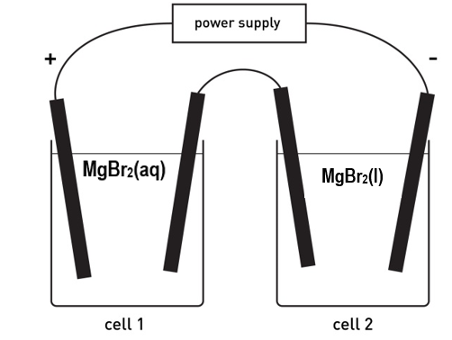

Question 15
The products formed will be

 | Cell 1 |  | Cell 2
 | Anode | Cathode | Anode | Cathode
A. | magnesium | bromine | magnesium | bromine
B. | oxygen | hydrogen | bromine | magnesium
C. | bromine | hydrogen | bromine | magnesium
D. | bromine | magnesium | bromine | magnesium

Question 16
A current of 965 amps is run through the circuit for 1 minute and 40 secs. The total mass of magnesium produced will be, in g,
A. 12.2
B. 24.3
C. 48.6
D. 97.2

Question 17
What is the IUPAC name for this compound?
A. but-2-en-3-ol
B. but-3-en-2-ol
C. 2-hydroxybutene
D. but-2-enol

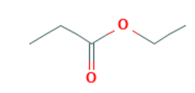
Question 18
The skeletal structure shown is
A. hexan-3-oic acid
B. propyl propanoate
C. ethyl propanoate
D. propyl ethanoate

Question 19
Which of the following will have the highest boiling point?
A. ethane
B. chloroethane
C. ethanol
D. ethanoic acid

Question 20
Methane is heated with excess chlorine gas in the presence of UV light. The number of different products possible is
A. 2
B. 3
C. 4
D. 5

Question 21
Which of the following reactions will have the highest atom economy?
A. Reaction of ethane and chlorine gas.
B. Reaction of ethene and chlorine gas.
C. Reaction of chloroethane and ammonia.
D. Reaction of ethanol and ethanoic acid.

Question 22
The ¹H NMR spectrum below could be for
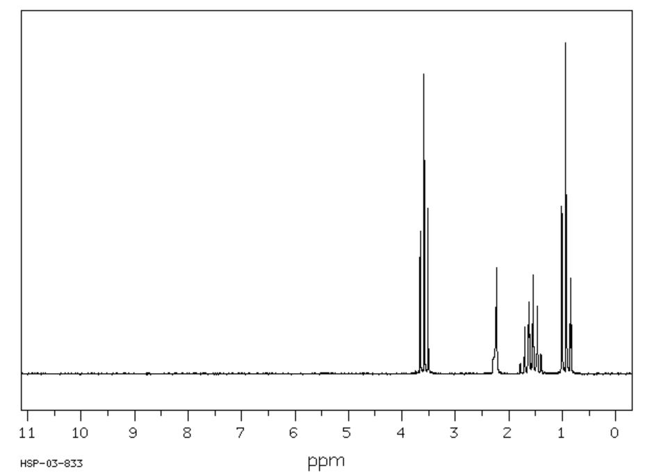
A. propan-1-ol
B. propan-2-ol
C. propanone
D. propanoic acid

Question 23
A HPLC chromatogram for a mixture of three fatty acids is shown below. A non-polar stationary phase was used.
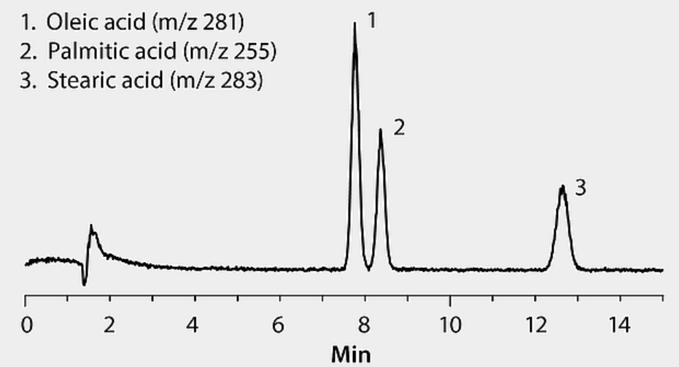
A valid conclusion from this chromatogram is
A. a non-polar stationary phase is not appropriate for fatty acids.
B. the concentration of palmitic acid is higher than that of stearic acid.
C. linolenic acid is likely to have a shorter retention time than the three fatty acids on the chromatogram.
D. retention time of fatty acids depends solely upon relative molecular mass.

Question 24
The molecular formula and molar mass of the methyl ester of linolenic acid will be, respectively,
A. C₁₈H₃₀O₂ and 278 g mol⁻¹
B. C₁₈H₃₂O₂ and 280 g mol⁻¹
C. C₁₉H₃₂O₂ and 292 g mol⁻¹
D. C₁₉H₃₄O₂ and 294 g mol⁻¹

Question 25
Which statement about coenzymes is correct?
A. Coenzymes can chemically react with a substrate.
B. Coenzymes can act with or without the presence of an enzyme.
C. Coenzymes are denatured by the addition of acid to a solution.
D. A coenzyme will work once only.

Question 26
A biomolecule is drawn below.
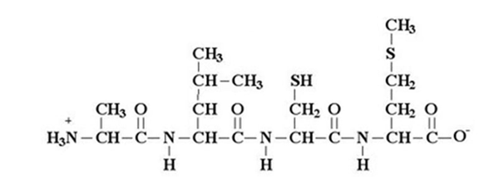

The diagram shows
A. a polypeptide formed from three amino acids.
B. a polypeptide formed from four amino acids.
C. a protein that has been denatured.
D. a segment of a protein molecule.

Question 27
Aspartame is often added to a food to provide a ‘diet’ alternative of that item.
A. The mass of aspartame required is far less than that of sugar.
B. Aspartame works because its level of sweetness is equivalent to that of sucrose.
C. Aspartame works because its energy density is over 100 times less than that of sucrose.
D. Aspartame works because the human body cannot metabolise it.

Question 28
2.22 g of biscuit is burnt under 80.0 g of water. The temperature change is 38.4 ºC. The heat of combustion of the biscuit is, in kJ g⁻¹,
A. 3.84
B. 5.78
C. 12.8
D. 5780

Use the following information to answer Questions 29 and 30
A solution of 1.0 M CuSO₄ is electrolysed for 3.0 minutes with a current of 2.0 amps. The copper electrodes are weighed before the current is switched on, then they are dried and reweighed after the current is turned off. Copper electrodes are used. The aim of the experiment is to investigate Faraday’s Laws.

Question 29
Which one of the following is likely to have little effect on the mass of copper obtained?
A. The surface area of the anode and cathode.
B. A student stirring the solution intermittently.
C. The conductivity of the solution decreasing as the experiment progresses.
D. The voltage from the power supply fluctuating.

Question 30
Which of the following will cause the mass change obtained to be higher than the predicted mass of copper?
A. The resistance of the solution increasing as the reaction proceeds.
B. The anode is not dried carefully.
C. The solution concentration gradually decreasing after many trials.
D. The cathode is not dried carefully.

Section B: Short answer questions

Question 1 (11 marks)
Australia has three bioethanol plants, all located near wheat or sugar processing plants. They use the waste materials from these plants to ferment monosaccharides to ethanol.
An alternative, small scale trial is in place in Gippsland near a forestry plant that is using waste bark and wood trimmings as a raw material. An outline of the plant is shown in the diagram below.
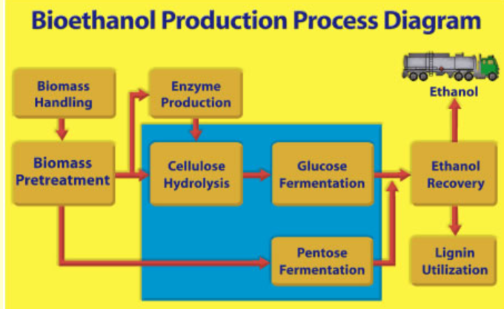
a. The volume of bioethanol produced in Australia is relatively low despite the high annual
production of both wheat and sugar.
Discuss reasons for this low production volume. 2 marks

_______________________________________________________________________________

_______________________________________________________________________________

b. The raw material for the production of bioethanol needs to be a form of carbohydrate.
What is the main form of carbohydrate in the bioethanol raw material from: 3 marks

i. wheat ____________________

ii. sugar cane ___________________

iii. forest waste? __________________

c. Suggest a reason why forest waste has not previously been used for bioethanol production.
1 mark
_______________________________________________________________________________

_______________________________________________________________________________

d. Write a balanced equation for the fermentation of glucose. 1 mark

____________________________________________________________________________

e. A 2.00 kg sample of ethanol undergoes complete combustion.
i. Calculate the energy released. 1 mark

______________________________________________________________________________

ii. The volume of CO₂ released at 280 ºC and 120 kPa. 3 marks

_______________________________________________________________________________

_______________________________________________________________________________

Question 2 (12 marks)
Ethyne, C₂H₂, is a gas used in industry to produce a high temperature flame. The flame is used to cut through metal. Ethyne can be produced from ethane in a reversible reaction.
C₂H₆(g) ⇄ C₂H₂(g) + 2H₂(g) ∆H = + 355 kJ mol
a. If an ethyne plant is run at 600 ºC and 100 kPa pressure, the yield is found to be low.
What will be the impact on the yield of ethyne if
i. the temperature is increased (Justify your answer). 2 marks

_______________________________________________________________________________

_______________________________________________________________________________

ii. the pressure is increased. 2 marks

_______________________________________________________________________________

_______________________________________________________________________________

b. The graph below shows the concentration of ethane gas after a sample is added to an
empty reactor.
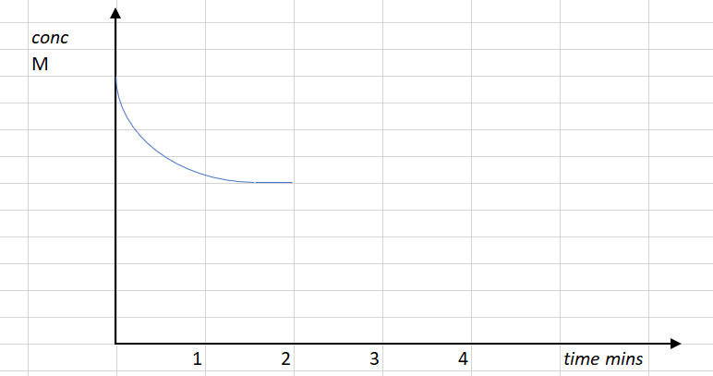

i. Draw on the graph the corresponding concentrations of ethyne and hydrogen gases. 2 marks

ii. At the two minute mark, the volume of the reactor is doubled. Draw, on the same graph, the
impact of this change on the ethane and show its likely response in returning to equilibrium.
2 marks

iii. Explain the impact of the volume change at the two minute mark on the rate of the forward
reaction. 2 marks

______________________________________________________________________________

______________________________________________________________________________

c. The other product in this reaction is hydrogen gas. Give an example of where society might use
hydrogen gas. Provide a balanced equation to support your answer. 2 marks

_______________________________________________________________________________

_______________________________________________________________________________

Question 3 (11 marks)
Fuel cell technology is very advanced. One of the limitations with fuel cells however is finding a cheap source of the fuel itself. One of newer lines of research is with glycerol as a fuel. The energy density of glycerol is not as high as some other fuels but its abundance compensates for its energy density.

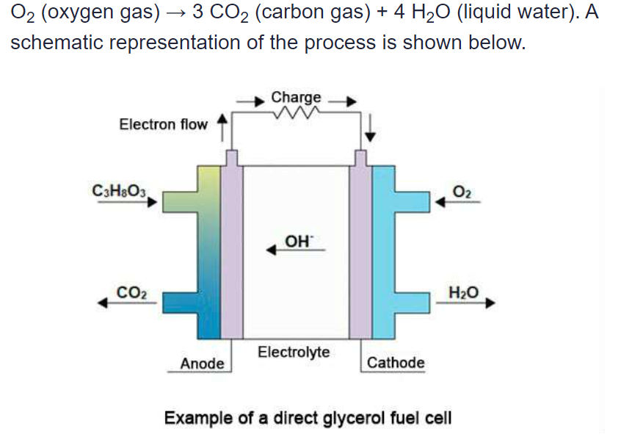
Glycerol is a cheap raw material. A fuel cell designed to run on glycerol is shown below.

a. Name an industry that is likely to produce glycerol as a by-product and explain how it is formed.
3 marks
_______________________________________________________________________________

_______________________________________________________________________________

_______________________________________________________________________________

b. Use the template below to determine the equations occurring in this cell: 3 marks

Anode: ________________________________________________________________________

Cathode: ________________________________________________________________________

Overall equation: __________________________________________________________________

c. Discuss the environmental and sustainability impact of largescale use of this cell. 3 marks

_______________________________________________________________________________

_______________________________________________________________________________

_______________________________________________________________________________

d. Will glycerol be soluble in water? Justify your answer. 2 marks

_______________________________________________________________________________

_______________________________________________________________________________

Question 4 (8 marks)
Fluorine gas is required for the polymer and pharmaceutical industries. As the gas is a dangerous gas to handle, it is often produced on-site using small electrolytic units. A sketch of a typical cell is shown below.
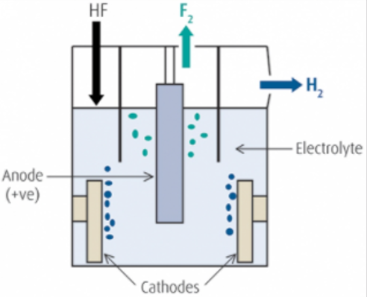

The electrolyte in this cell is hydrogen fluoride, HF, that is dissolved in molten KHF₂ to make a conductive liquid. The anode in the cell is platinum and the cathode iron.

a. Use the headings below to write half-equations and an overall equation for the reactions
occurring. 3 marks

Anode: ________________________________________________________

Cathode: ________________________________________________________

Overall equation: ________________________________________________________

b. What is the minimum voltage required to power this cell? _________________ 1 mark

c. How will the mass of hydrogen gas formed in the cell compare to the mass of fluorine gas?
2 marks
___________________________________________________________________________

____________________________________________________________________________

d. List and justify two precautions the operators of this cell would need to take. 2 marks
___________________________________________________________________________

____________________________________________________________________________
Question 5 (6 marks)
If you cut a banana into pieces and leave the pieces on the bench, they will gradually turn brown over the next few hours. This is a result of the reaction between the phenols in the banana and oxygen from the air. The phenols react to form polyphenols which are brown in colour. An enzyme called polyphenol oxidase in bananas acts as a catalyst for this reaction.

a. Should you cut the bananas into big or small pieces to limit browning? Discuss. 2 marks

____________________________________________________________________________

____________________________________________________________________________

b. A student’s mother suggests that the addition of fruit juice helps limit browning. A student tests
this be pouring 5 mL of the following fruit juices over similar pieces of cut bananas. This testing
results are summarised below.

Juice | Ranking (least browning)
Grapefruit juice | 2
Lemon juice | 1
Orange juice | 3

Using your knowledge of chemistry, explain why the fruit juice limits browning and suggest why
lemon juice might be the most effective juice. 3 marks

_____________________________________________________________________________

_____________________________________________________________________________

______________________________________________________________________________

______________________________________________________________________________

c. Vitamin C solution is also effective in preserving the appearance of the bananas, but it works for a
different reason than the fruit juice in part b. Suggest a reason why vitamin C might prevent
browning of bananas. 1 mark

______________________________________________________________________________

Question 6 (7 marks)
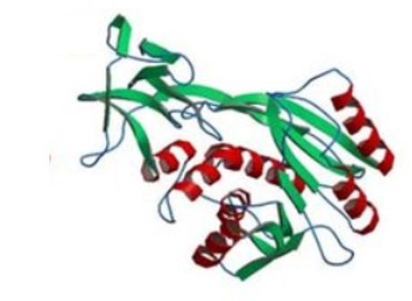
A segment of a protein is pictured below.

a. Annotate this diagram to identify the two main types of secondary structure that occur in
proteins. Explain why proteins have a secondary structure. 2 marks

_______________________________________________________________________________

_______________________________________________________________________________

b. The tertiary structure of a protein is due to several bonding types between different parts of a
protein or between different protein molecules.

i. Name an amino acid that has an R-group that can form a covalent bond with itself.
Draw the covalent bond. 2 marks

_______________________________________________________________________________

_______________________________________________________________________________

ii. Name two amino acids that can have R-groups that can form an ionic bond.
Draw what that bond looks like. 2 marks

_______________________________________________________________________________

_______________________________________________________________________________

iii. Name two different amino acids that can form hydrogen bonds with each other. 1 mark

_______________________________________________________________________________

Question 7 (11 marks)
A sample of an organic compound is tested to try and deduce its structure. It is known to contain carbon, hydrogen and oxygen only. The spectra in this question are provided to help you deduce the identity of the unknown compound.
a. The mass spectrum of the compound is shown below.
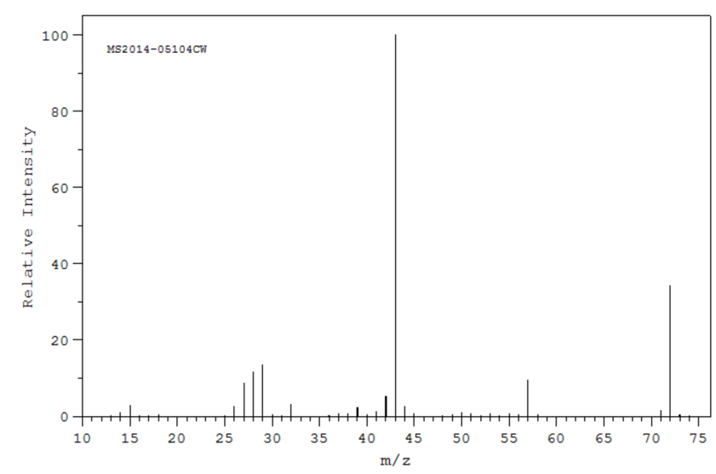
i. Suggest a fragment from this substance that might have produced the base peak shown
on the spectrum. _________________ 1 mark

ii. Use the space provided below to draw two molecules with a molecular formula consistent
with the parent molecular ion value. 2 marks

b. The infrared spectrum of the unknown compound is shown below.
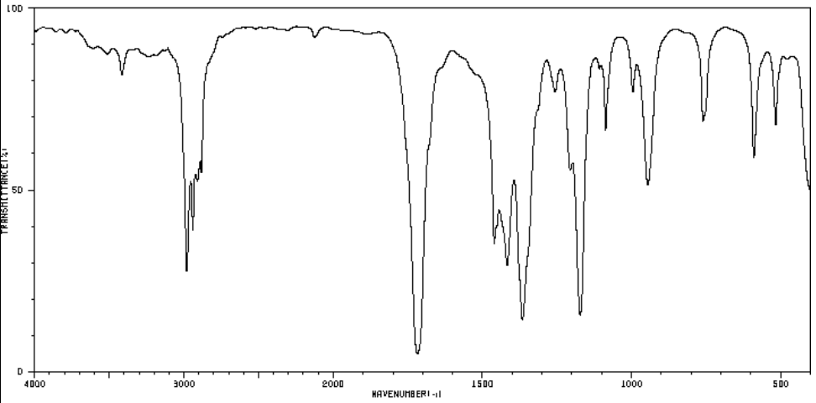

Suggest two useful conclusions that can be drawn from this spectrum. Justify each conclusion.
2 marks
___________________________________________________________________________

____________________________________________________________________________

c. The ¹H-NMR and ¹³C-NMR spectra for the unknown compound are both shown below.
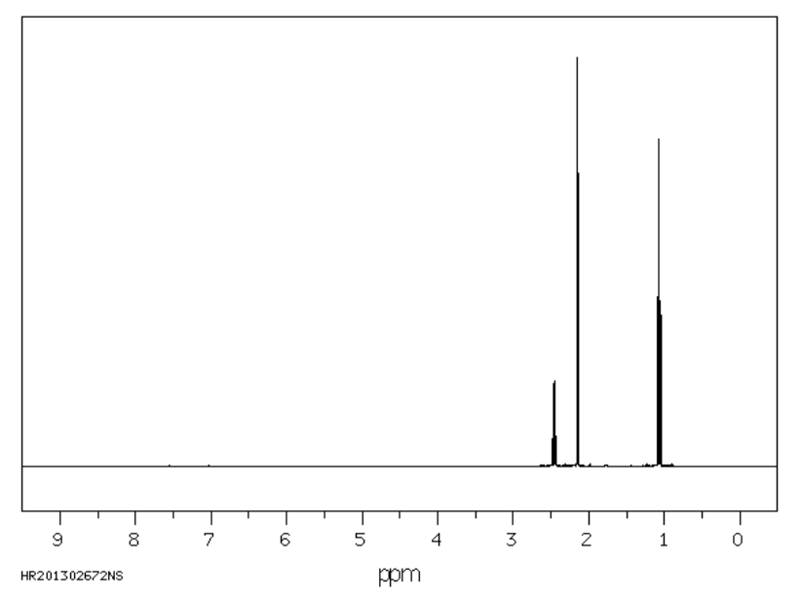
¹H NMR: From left to right-
- quartet
- singlet
- triplet

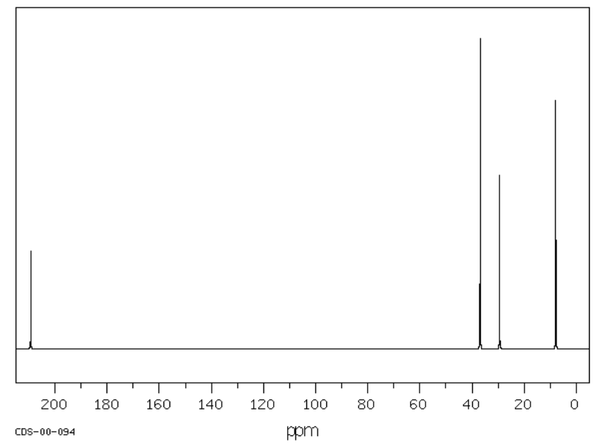

Combine all the data provided to draw the structure of the compound. Explain how the NMR
data supports your conclusion. 4 marks

__________________________________________________________________________

__________________________________________________________________________

__________________________________________________________________________

___________________________________________________________________________

____________________________________________________________________________

d. Use the boxes provided to draw the structure of a molecule that could be used to synthesise the
unknown compound. Also show the reagents required for this reaction. 2 marks

Other reagent(s)

Unknown compound

Question 8 (7 marks)
a. Propan-1-ol and propan-2-ol have very similar properties.
What chemical reaction could you use to distinguish between these alcohols and what different
outcomes would occur? 3 marks

_______________________________________________________________________________

_______________________________________________________________________________

_______________________________________________________________________________

_______________________________________________________________________________

b. Butanoic acid is an isomer of methyl propanoate. Both are colourless liquids.
How could you test a sample of one of these liquids, without a chemical reaction, to identify
which liquid it is? How will the outcomes differ depending upon the liquid? 2 marks

_______________________________________________________________________________

_______________________________________________________________________________

c. Two different labs produce separate samples of oleic acid. The sample from one laboratory has a
melting point 30 ºC higher than the sample from the other laboratory.
Suggest a structural reason for the differing melting points. 1 mark

_______________________________________________________________________________

_______________________________________________________________________________

d. Two separate samples of the molecule CH₃CH₂CHOHCl produce different effects on polarised
light. Explain why. 1 mark

_______________________________________________________________________________

_______________________________________________________________________________

Question 9 (8 marks)
A class is investigating different aspects of determining the heat of combustion of peanuts.

One of the students uses the setup shown below, where a peanut is held in a wire holder and burnt under a soft drink can containing 100 g of water. The student is investigating the impact of changing the distance between the flame and the can of water.
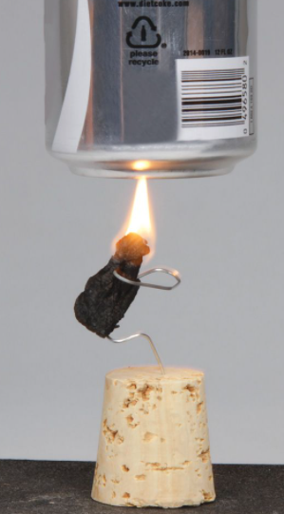
Some of the student’s notes are shown below.
Hypothesis: There will be an optimum distance between the nut and the can.

Experiment | Separation distance (cm) | ∆T ºC
1 | 1.0 | 12.3
2 | 2.0 | 14.2
3 | 3.0 | 16.1
4 | 4.0 | 15.1
5 | 4.0 | 14.5
6 | 4.0 | 15.8
7 | 5.0 | 13.6
8 | 6.0 | 9.4

Experiment 3: Mass of peanut: 1.12 g
Final temperature: 38.6 ºC
Initial temperature 19.2 ºC

a. For this experiment, identify the 2 marks

- dependent variable ___________________________________________

- independent variable __________________________________________

b. Discuss the data obtained from experiments 4, 5 and 6 and relate your comments to the
experiment design. 2 marks

_______________________________________________________________________________

_______________________________________________________________________________

c. What conclusion do you think the student could draw from this experiment? 2 marks

_______________________________________________________________________________

_______________________________________________________________________________

d. The documented value for a peanut is 26.5 kJ g. 2 marks
Use the data from experiment 3 to determine the percentage efficiency of the student apparatus.

_______________________________________________________________________________

_______________________________________________________________________________

Question 10 (9 marks)
The molecules drawn below are methanamine and ethanamine.
These two compounds are the first members of the homologous series of primary amines.

a. Use your knowledge of bonding to discuss some likely properties of methanamine, then use
amines as an example to explain
- what a homologous series is
- how a knowledge of what a homologous series is can be useful to a chemist.
Include in your answer discussion of likely trends in properties of the amine group.
4 marks
___________________________________________________________________________

___________________________________________________________________________

___________________________________________________________________________

___________________________________________________________________________

b. An acid-base titration can be used to determine the concentration of a strong solution of
ethanamine.
Outline in detail a procedure that could be used to determine the concentration of a solution of
ethanamine.
Include in your answer a discussion of other reagents required and a balanced equation for the
reaction occurring. 5 marks

___________________________________________________________________________

___________________________________________________________________________

___________________________________________________________________________

___________________________________________________________________________

___________________________________________________________________________

___________________________________________________________________________

___________________________________________________________________________

___________________________________________________________________________

End of Exam
Mark section A: /30
Mark section B: /90
Total: /120

